UNIVERSITÉ INTERNATIONALE DE RABAT
ESIN – Génie Informatique
Big Data & Intelligence Artificielle
PROJET Compter Vision
Barcode & QR Code Scanner and Localizer
Réalisé par :
Abdallah ALNAJJAR – Fahd CHAIB – Mohammed Houssam ALJEBBAR
Encadré par :
Ilias TOUGUI
Année universitaire :
2025 – 2026

Barcode and QR Code Scanner

1. Introduction
Barcodes and QR codes are widely used in modern applications such as product identification, logistics, authentication, and digital communication. These codes store information in a visual format that can be easily scanned and decoded.
In this project, we aim to design and implement a system capable of detecting and decoding barcodes and QR codes from images. The system takes an input image, processes it using computer vision techniques, identifies regions containing codes, and extracts the encoded information.
The main objective is to build a complete pipeline that is both efficient and easy to use. Unlike complex deep learning systems, this project focuses on classical computer vision methods, which are easier to implement and require less computational resources.
In addition, a graphical interface is developed to allow users to interact with the system in a simple way by uploading images and visualizing the results directly.

2. Methodology
The proposed system follows a structured pipeline composed of several steps.
First, image preprocessing is applied. The input image is converted to grayscale to reduce complexity and focus only on intensity values. Then, Gaussian blur is applied to smooth the image and reduce noise, which improves the performance of edge detection.
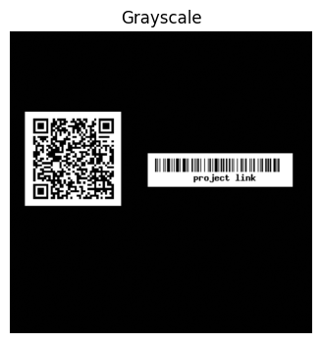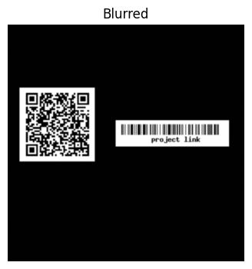
The next step is edge detection using the Canny algorithm. This method detects strong intensity gradients and highlights important structures in the image. Barcodes and QR codes typically have clear edges, making this step essential for identifying potential regions of interest.
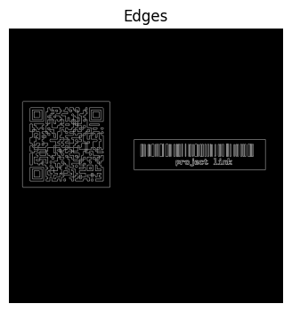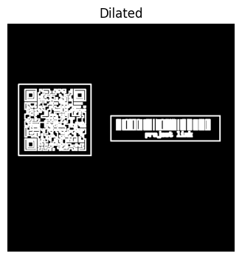
After detecting edges, a dilation operation is applied. This step connects broken edges and strengthens the shapes, allowing better contour detection.
Contours are then extracted from the processed image. Each contour represents a potential region containing a barcode or QR code. To reduce false detections, small regions are filtered out based on their size.
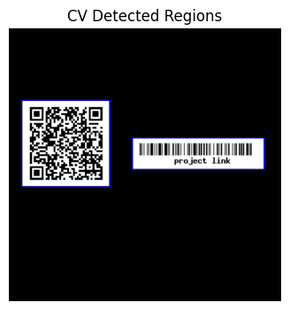
Once candidate regions are identified, decoding is performed using the pyzbar library. This library analyzes the image and extracts the encoded information from the detected codes.
Finally, the results are visualized by drawing bounding boxes around detected codes and displaying their decoded values on the image.
In addition to the core pipeline, an interactive graphical interface is implemented using ipywidgets. This interface allows users to upload an image, run the detection process, and instantly view the results.

3. Results
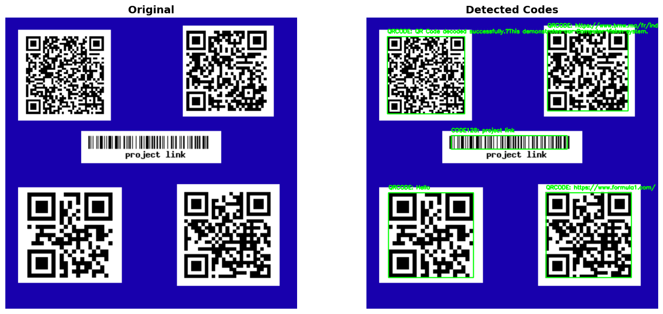
The system was evaluated using multiple test images containing different types of barcodes and QR codes.
The results show that the system is able to successfully detect and decode codes in most standard conditions. It performs well when images are clear, properly illuminated, and not excessively distorted.
In images containing multiple codes, the system is capable of identifying several regions and decoding each code independently.
The batch processing function demonstrates the ability of the system to handle multiple images in sequence. This confirms the robustness of the pipeline when applied to datasets.
The graphical interface provides a clear and user-friendly visualization. Users can easily compare the original image with the detected output, making the system practical and intuitive.
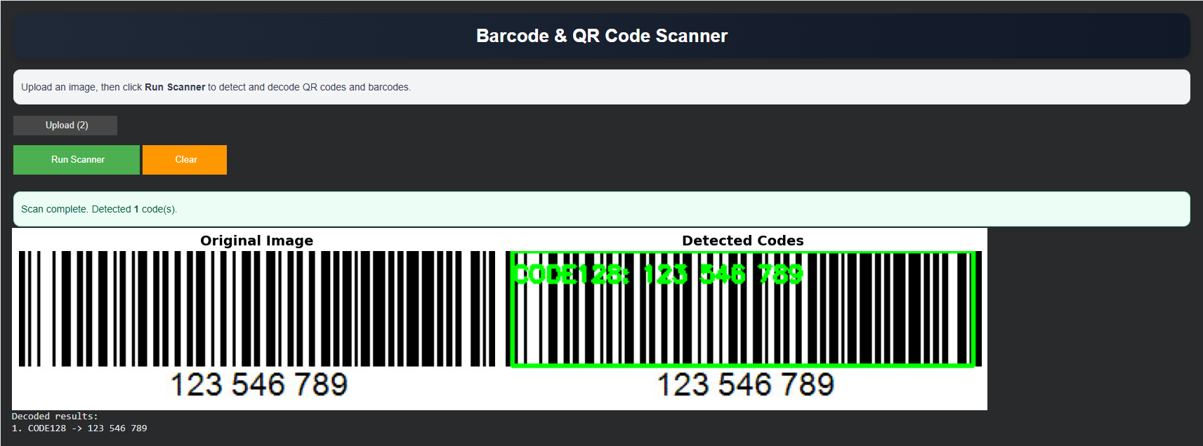

4. Discussion
The main advantage of this approach is its simplicity. By relying on classical computer vision techniques, the system does not require training data or complex models.
This makes the system fast, lightweight, and easy to deploy. It is also easier to understand and explain, which is important for educational purposes.
However, the system has some limitations. It may struggle with low-quality images, such as those that are blurry, very dark, or contain heavy noise.
In such cases, edge detection may fail, leading to incorrect or missing detections. Additionally, the contour-based approach may sometimes detect irrelevant regions.
Another limitation is the dependency on the pyzbar library for decoding. While it is reliable, it reduces the level of control over the decoding process.
Despite these limitations, the system remains effective for many practical use cases and demonstrates the power of classical techniques.

5. Conclusion
In this project, we developed a complete system for detecting and decoding barcodes and QR codes from images.
The solution combines preprocessing, edge detection, contour analysis, and decoding techniques to achieve reliable results.
The addition of an interactive interface improves usability and makes the system accessible to users without technical knowledge.
Overall, the project demonstrates that classical computer vision techniques can be effectively used to solve real-world problems.
For future work, several improvements can be considered. These include real-time detection using a camera, integration of deep learning models for better accuracy, and deployment as a mobile or web application.
Such improvements would enhance the performance and extend the usability of the system in real-world scenarios.

